Adaptive Cognitive Load Prediction System for Online Learning Using Behavioral Patterns
R26-SE-004

Project Proposal Report
Jayasinghe J.M.S.N. – IT22166074

B.Sc. (Hons) Degree in Information Technology Specialized in
Software Engineering

Department of Software Engineering

Sri Lanka Institute of Information Technology Sri Lanka

March 2026

DECLARATION

I declare that this is my own work, and this proposal does not knowingly incorporate any material previously submitted for a degree or diploma at any other university or higher education institution, nor does it contain any material that has been previously published or written by another person apart from where proper acknowledgment is given in the text.

Name | Student ID | Signature
Jayasinghe J. M. S. N. | IT22166074 | 

The above candidate is conducting research for their undergraduate Dissertation under my supervision.

Name | Date | Signature
Dr. Kalpani Manathunga | 3/15/2026

ABSTRACT

Standardized e-learning platforms such as Blackboard and Moodle primarily emphasize technical functionality rather than addressing the individual needs of learners. As a result, they often overlook students’ diverse backgrounds, interests, and real-world contexts. This “one-size-fits-all” approach has contributed to a growing crisis of relevance in digital education, leading to reduced engagement, increased boredom, and higher dropout rates among students. Despite advancements in adaptive learning technologies, many existing systems focus mainly on adjusting the sequence or difficulty of lessons rather than transforming the learning content itself.
This research identifies a critical gap in current adaptive learning systems: the lack of integrated mechanisms that simultaneously consider learners’ cognitive styles and real-time cognitive load to dynamically transform educational content during a lesson. To address this limitation, the study proposes an AI-driven Transformation Engine that utilizes GPT-4 to convert standard educational materials into personalized learning artifacts. The system integrates three real-time inputs: the learner’s profile, cognitive style, and real-time cognitive load indicating mental effort.
The proposed system employs a multimodal data processing pipeline to extract learning content from multiple formats, including PDFs, slides, and videos. Tools such as pdfminer, BeautifulSoup, pydub, and OCR are used for data extraction, while text refinement is performed using clean-text and pyspellchecker before storing the information in a structured knowledge base. GPT-4 then generates personalized instructional content using tailored prompts and contextual data from the knowledge base.
Expected outcomes include a projected improvement of approximately 20% in student academic performance and a reduction in cognitive overload. The system also aims to significantly reduce time-to-mastery while maintaining high levels of learner engagement. Beyond educational improvements, the proposed framework supports global goals for inclusive education and offers potential for scalable implementation in higher education institutions.

Keywords: Adaptive Learning, GPT-4, Cognitive Load, Content Personalization, Student Engagement.

ACKNOWLEDGEMENT

I would like to express my sincere gratitude to our research supervisor, Dr. Kalpani Manthunga, for her continuous guidance, encouragement, and valuable feedback throughout the progress of this research project. Her expertise, constructive suggestions, and support greatly helped us to shape and improve the direction of this study.
I would also like to extend my sincere appreciation to our research co-supervisor, Mr. Jeewaka Perera, for his helpful advice, technical guidance, and encouragement during the development of this research work. His insights were extremely valuable in strengthening the quality of this project.
My sincere thanks are also extended to Prof. Koliya Pulasinghe, the Lecturer-in-Charge of the Research Project module, for providing academic guidance, motivation, and support during the research process.
Finally, I would like to thank my research group members, Rajitha Subasinghe, Wimukthi Dilshan, and Imesh Liyanaarachchi, for their cooperation, discussions, and support throughout the project.

TABLE OF CONTENT (Auto Generated)

Contents
DECLARATION 2
ABSTRACT 3
ACKNOWLEDGEMENT 4
TABLE OF CONTENT (Auto Generated) 5
LIST OF TABLES 7
LIST OF FIGURES 8
LIST OF ABBREVIATIONS 9
1.INTRODUCTION 10
1.1 Background and Context 10
Problem Statement 10
Stakeholders and Impact 10
Statistical Evidence 11
Analysis of Existing Solutions and their limitations 13
Ideas for the proposed solution and its parts 14
Alignment with Sustainable Development Goals (SDGs) 15
Research cluster alignment 16
1.2 Literature Review 17
1.3 Research Gap 19
Existing System Limitations 19
Weaknesses in Existing Approaches 19
Justification of the Proposed Method’s Novelty 19
Argument Supported by Evidence 20
2.OBJECTIVE 21
2.1 Main Objective 21
2.2 Specific Objectives 21
3.METHODOLOGY 22
Research approach 22
Technical methods and algorithms 22
Tools and Platforms Used with Justification 23
Data collection and ethical considerations 23
Validation strategy and performance metrics 23
4.HIGH-LEVEL SYSTEM ARCHITECTURE 25
System Overview 25
Overview of proposed solution and its components 26
System Component Diagram 26
System Component and Subcomponents 27
Interaction Between System Components 28
Data Flow in the System 28
Scalability and Security Considerations 29
5.USER REQUIREMENTS 30
Stakeholder Identification 30
Non-functional requirements 31
6.COMMERCIALIZATION PLAN 32
Target market and customer persona 32
Value proposition 33
Revenue model 33
Cost estimation 34
Pricing strategy 35
Competitive advantage 36
Intellectual property considerations 37
7.BUDGET AND JUSTIFICATION 38
8.WORK BREAKDOWN STRUCTURE (WBS) 40
9.GANTT CHART 41
10.REFERENCES LIST 42
11. APPENDICES 44

LIST OF TABLES
Table 1 9
Table 2 39
Table 3 41

LIST OF FIGURES

Figure 1 12
Figure 2 13
Figure 3 13
Figure 4 - High-Level Architecture of the Adaptive Cognitive Load Prediction System 25
Figure 5 - High-Level System Component and Data Flow of the Personalization Engine 26
Figure 6 – Gantt Chart 41

LIST OF ABBREVIATIONS
Table 1 – List of Abbreviations
Abbreviation | Full Form
AI | Artificial Intelligence
AIGC | Artificial Intelligence Generated Content
ASR | Automatic Speech Recognition
API | Application Programming Interface
CV | Computer Vision
DBR | Design-Based Research
GPT | Generative Pre-trained Transformer
HK-PLRM | Hybrid Knowledge-Enhanced Personalized Learning Recommendation Model
IDE | Integrated Development Environment
LMS | Learning Management System
LLM | Large Language Model
MOOC | Massive Open Online Course
NLP | Natural Language Processing
OCR | Optical Character Recognition
PAGE | Psychologically Aware Generative Education
PDF | Portable Document Format
PII | Personally Identifiable Information
PPT | PowerPoint Presentation
RAG | Retrieval-Augmented Generation
SDG | Sustainable Development Goal
SaaS | Software as a Service
STREAM | Structured Transformation for Educational Adaptive Models
WBS | Work Breakdown Structure
WER | Word Error Rate
ZPD | Zone of Proximal Development

1.INTRODUCTION

1.1 Background and Context

Problem Statement
Standardized, “one-size-fits-all” e-learning platforms such as Blackboard and Moodle predominantly focus on technical functionality while ignoring individual pedagogical needs and the unique backgrounds of undergraduate students [1], [2]. This delivery model often presents generic, static instructional materials that fail to connect with a student's personal interests or real-world context, leading to what researchers describe as a “crisis of relevance” and “affective disengagement” [2], [3]. Consequently, students struggle to see the value of abstract knowledge, which manifests in high dropout rates, pervasive boredom, and a profound lack of motivation [1], [2].
A critical component of this struggle is the mismatch between the system’s delivery and the learner’s cognitive and psychological profile [1], [4]. Most contemporary systems fail to account for a student's cognitive style or real-time cognitive load, often overwhelming them with inappropriate amounts of information or failing to provide the necessary scaffolding [3], [5]. Because these platforms neglect non-cognitive factors such as personality traits, emotional states, and preferred exposition styles there is a significant disconnection between the educator's presentation and the student's genuine learning requirements [4]. This “psychological blind spot” results in cognitive overload, increased learner frustration, and an environment where students feel “lost” because the content assumes a level of background or processing style they do not possess [4].

Stakeholders and Impact
The standardized “one-size-fits-all” approach of most contemporary e-learning platforms primarily impacts the online learning community, including undergraduate students and distance learners who rely on digital environments for higher education [1], [3]. Addressing this problem is essential because students often face a “crisis of relevance” and affective disengagement when static instructional materials ignore their unique psychological backgrounds and learning preferences [1], [2], [3]. These disconnects between the system, and the user leads to serious consequences, such as high dropout rates, pervasive boredom, and cognitive overload, which hinder a student's ability to internalize knowledge effectively [1], [6]. Consequently, moving beyond static delivery to provide adaptive, learner-centered instruction is important for promoting educational equity and ensuring that students from diverse cognitive and socioeconomic backgrounds can achieve improved learning outcomes and sustained motivation [7].

Statistical Evidence

High Attrition and Performance Disparities
Traditional static e-learning models are frequently associated with poor student retention and lower academic achievement when compared with adaptive and personalized learning environments. Empirical research indicates a clear performance gap between these approaches. A meta-analysis of adaptive learning studies reports that students in adaptive environments perform approximately 15% better in assessments than those in non-adaptive, static learning systems [8], [9].
Furthermore, traditional rule-based instructional design methods demonstrate relatively limited instructional effectiveness. Comparative experimental studies show that conventional methods lead to only a 10.04% improvement in student performance, whereas AI-driven personalized learning systems achieve an improvement of approximately 20.26% [5].
In addition to performance disparities, standardized e-learning platforms contribute to the high dropout rates commonly observed in online education, particularly in Massive Open Online Courses (MOOCs) [10]. Experimental evidence indicates that learners using traditional static systems experience a dropout rate of approximately 24%, which can be reduced to 12% through adaptive learning interventions. This issue is particularly significant for students with high neuroticism, who are more susceptible to frustration. In static systems, dropout rates for this group can reach 38%, whereas psychologically adaptive learning environments reduce the rate to approximately 15%

.

Affective Disengagement and Cognitive Load
Static instructional delivery models often fail to maintain learner engagement and effectively manage cognitive load. Studies indicate that learners using traditional static systems report an engagement rate of approximately 65%, whereas reinforcement-learning-based adaptive systems achieve engagement levels of up to 92% by dynamically adapting instructional content according to real-time learner progress [6].
Adaptive learning systems also improve learning efficiency. As shown in Fig. 1, the traditional static model requires approximately 12 hours for concept mastery, while collaborative filtering models reduce this to about 9 hours. The reinforcement-learning-based adaptive model further reduces the learning time to approximately 6 hours, demonstrating improved instructional efficiency.

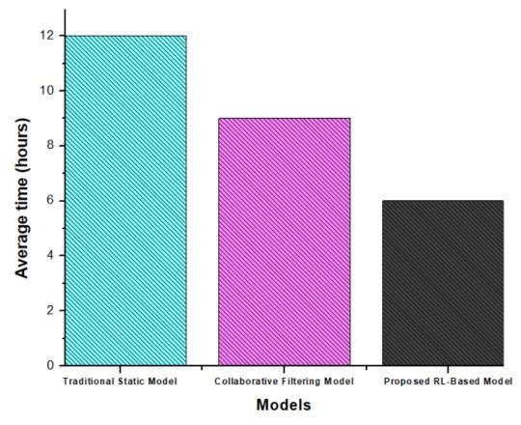
Figure 1

In addition to reducing learning time, adaptive systems significantly improve overall system efficiency. As illustrated in Fig. 2, traditional static models achieve an efficiency score of around 70, while collaborative filtering models reach approximately 85. The reinforcement-learning-based model achieves the highest efficiency score of 95, highlighting the benefits of adaptive personalization.

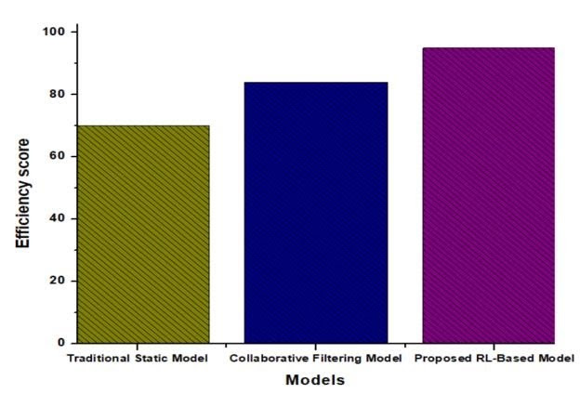
Figure 2

Adaptive systems also increase learner engagement. As shown in Fig. 3, traditional static systems achieve an engagement rate of approximately 65%, while collaborative filtering models reach around 78%. The reinforcement-learning-based model achieves the highest engagement level of 92%.
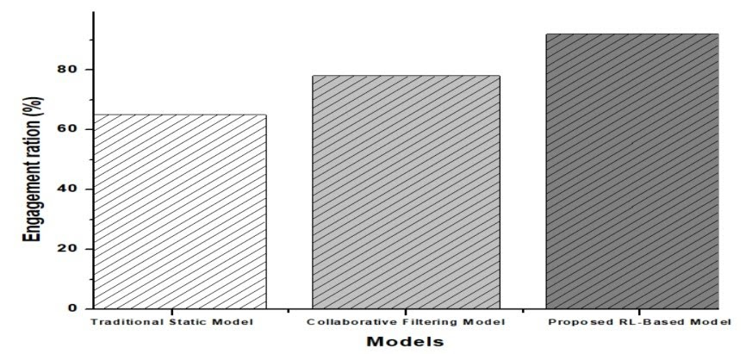
Figure 3

Analysis of Existing Solutions and their limitations

Standardized e-learning platforms such as Blackboard, Moodle, and Canvas have significantly expanded access to digital education; however, they often prioritize technical functionality over individual learner needs [1]. These platforms typically employ a “one-size-fits-all” instructional delivery model, providing generic and static learning materials that frequently overlook a learner’s unique academic background and real-world context [2]. As a result, several studies have identified a “crisis of relevance” and affective disengagement, where undergraduate students experience boredom and frustration because they struggle to connect abstract academic concepts with their personal experiences [2], [3].

To address these limitations, several adaptive learning systems such as ALEKS, Khan Academy, and Smart Sparrow attempt to personalize learning pathways by adjusting content sequencing based on learner performance and difficulty progression [8]. However, these solutions remain fragmented and limited in scope, as many rely on predefined rule-based adaptation and static learner models rather than dynamic personalization mechanisms [3]. A key limitation of these systems is their inability to perform deep content transformation within the learning material itself. Studies indicate that approximately 85% of existing instructional content remains in a fixed textual format, which limits the ability to support diverse cognitive styles or enable real-time multimodal adaptations [3].

Furthermore, many existing personalized learning systems exhibit a “psychological blind spot,” focusing primarily on cognitive performance while overlooking non-cognitive learner characteristics such as personality traits and real-time emotional states [4]. Although emerging Generative AI (AIGC) approaches offer promising opportunities for scalable personalization, current implementations often provide only superficial adaptation, such as adjusting text complexity. These systems also face technical challenges, including factual “hallucinations” and insufficient pedagogical grounding [2], [5]. Consequently, the misalignment between instructional delivery and a learner’s cognitive load or psychological profile may lead to inappropriate information density, leaving students feeling overwhelmed or disconnected from content that assumes prior knowledge they do not possess [5].

Ideas for the proposed solution and its parts
- The solution is an AI-driven Retrieval-Augmented Generation (RAG) platform that transforms static educator materials into dynamic, personalized artifacts based on a three-dimensional user input: User Profile, Cognitive Style, and Real-Time Cognitive Load.
- Multimodal Resource Extraction: To overcome the "format monotony" of textual e-learning, the system uses a pipeline including pdfminer and BeautifulSoup for documents, and pydub, OCR, and OpenVoice for audio-visual extraction [3]. This allows the system to decompose teacher-provided materials (PDFs, PPTs, videos) into discrete, semantically tagged knowledge units .
- Data Cleaning and Normalization: Extracted text is refined using clean-text and pyspellchecker to remove noise and correct errors, ensuring high-quality input for the generative engine [11].
- Chunk-Wise Knowledge Base: The processed units are stored in a structured database as "knowledge objects" (definitions, steps, examples), maintaining 100% back-link coverage to the original source timestamps for instructional transparency.
- Context-Aware Prompt Builder: A specialized module synthesizes the User Profile (major, interests), Cognitive Style (visual, verbal), and Dynamic Load into a tailored prompt.
- Transformation Engine (GPT-4): GPT-4 processes the prompt and relevant knowledge chunks to regenerate content. For instance, it can convert a complex neural network explanation into a "video game quest log" analogy for a student interested in gaming, or shift to simplified, scaffolded diagrams if "high cognitive load" is detected.

Alignment with Sustainable Development Goals (SDGs)
- The proposed system aligns with the United Nations Sustainable Development Goals (SDGs) by leveraging AI to democratize and humanize education.
- SDG 4 (Quality Education): This is the primary alignment. AIGC-driven personalization ensures inclusive and equitable quality education by adapting materials to individual cognitive capacities and learning paces [9].
- SDG 10 (Reduced Inequalities): By providing tailored instruction for diverse online learners including those from different socioeconomic or academic backgrounds the system helps bridge achievement gaps and promotes educational equity.
- SDG 8 (Decent Work and Economic Growth): Personalized skill development and faster knowledge acquisition (e.g., reducing time-to-mastery from 12 hours to 6 hours) better equip students for the modern workforce.

Research cluster alignment
- The system maps directly onto several critical research domains identified in the bibliometric analysis of adaptive learning literature [9].
- Cluster 1 (Intelligence Learning): The system integrates AI technology into adaptive settings to create an intelligent environment that responds to learner-computer interactions [9].
- Cluster 2 (Parameter Prediction): The core novelty is the parallel tracking of parameters (cognitive load and style) to anticipate a student's immediate needs and prevent frustration through real-time format conversion.
- Cluster 3 (Dataset Classification): The system utilizes NLP and planned Computer Vision (CV) to categorize complex multimodal datasets (transcripts, images, slides) into tagged knowledge units for further analysis [3].
- Psychologically-Aware Education: It bridges the "psychological blind spot" by extending beyond cognitive performance to incorporate personality traits and real-time affective states (frustration, confusion) into the content generation logic [4].

1.2 Literature Review
Standard e-learning platforms such as Blackboard and Moodle are widely used but often prioritize technical functionality over individual pedagogical needs [1]. Recent AI-enabled services such as Khan Academy, Coursera, Duolingo, and Knewton provide personalized learning paths based on performance history [12]. Similarly, platforms like DreamBox and Smart Sparrow use real-time interaction data to adapt lessons and learning pathways [3], [12]. However, many contemporary systems still focus mainly on content sequencing rather than deep instructional transformation [3]. Consequently, AI-driven educational technology is increasingly reshaping modern digital learning environments [7].
Current research on content personalization emphasizes advanced learner models that extend beyond simple performance tracking [1], [13]. Studies now integrate multidimensional behavioral data to capture cognitive traits, personality characteristics, and emotional states [4], [5], [13]. For example, Psychologically Aware Generative Education (PAGE) adapts learning materials using Big Five personality traits and affective feedback to improve engagement [4]. These approaches commonly employ reinforcement learning and transformer-based architectures to dynamically adjust instructional difficulty and presentation [5], enabling more responsive learner-centered environments [6].
Another important research direction involves automated knowledge extraction and the creation of personalized knowledge bases to support adaptive delivery [13]. Techniques such as BERT-based key phrase extraction and semantic parsing identify “knowledge points” from multimodal learning data [1], [3]. Models such as the Hybrid Knowledge-Enhanced Personalized Learning Recommendation Model (HK-PLRM) utilize knowledge graph embeddings to represent semantic relationships between learning resources and exercises [13]. Additionally, Generative Artificial Intelligence (AIGC) is increasingly used to produce auxiliary learning materials such as summaries, quizzes, and interactive explanations derived from open educational resources [10], helping improve engagement and knowledge retention [10].
Despite these advancements, several limitations remain in current e-learning systems, often creating a “crisis of relevance” for learners [2]. A major limitation is the “psychological blind spot,” where systems focus primarily on cognitive performance while neglecting non-cognitive factors such as motivation, anxiety, and personality-driven learning styles [4]. Many platforms also rely heavily on static instructional materials without within-lesson multimodal transformation, leading to mismatches between instructional delivery and learner processing needs [3]. Furthermore, large language models used for personalization may produce factual inaccuracies or “hallucinations” and often struggle to adapt content appropriately to different education levels [5], [14]. Standardized models also rely on generalized patterns derived from large datasets, which limits their effectiveness for individual learners [1].
To address these challenges, recent research is shifting toward more human-centered and pedagogically grounded AIGC-based learning environments [5]. Frameworks such as STREAM and PAGE aim to enable real-time content decomposition and regeneration into alternative learner-aligned formats [3]. These systems seek to reduce extraneous cognitive load by contextualizing abstract concepts within familiar contexts while maintaining instructional rigor through knowledge-regulated retrieval [2]. Moving beyond “one-size-fits-all” instructional models is therefore essential for improving educational equity and sustaining long-term learner motivation in digital learning environments [3], [5].
However, a significant gap remains in existing research: very few systems simultaneously consider real-time cognitive load and the specific cognitive style of the learner [4]. While some studies use multimodal data such as eye-tracking to estimate cognitive load [5], and others incorporate personality traits or emotional feedback into content generation, most systems still personalize learning only through performance-based adjustments such as difficulty or sequencing [4]. As a result, a mismatch often persists between generated instructional content and the learner’s moment-to-moment cognitive requirements. Addressing this limitation represents a critical research challenge for future adaptive learning systems [5].

1.3 Research Gap

Existing System Limitations
A significant void in existing research is the absence of an integrated system that simultaneously considers and adapts to both real-time cognitive load and the specific cognitive style of the learner [1], [3]. While current frameworks like STREAM and PAGE have introduced mechanisms for content decomposition and personality-based adaptation, they primarily focus on static profiling or performance-based sequencing [3], [4]. There is currently no robust mechanism in literature that performs parallel tracking of a learner’s mental workload to dynamically convert instructional formats (e.g., shifting from complex text to a scaffolded diagram) the moment cognitive overload is detected [5].

Weaknesses in Existing Approaches
Most contemporary "adaptive" platforms suffer from a “psychological blind spot,” where they prioritize technical functionality and performance history (such as quiz scores) over the learner’s immediate internal mental state [7]. These systems are largely static in their delivery, with approximately 85% of content remaining in a fixed textual format, which fails to accommodate diverse cognitive styles or mitigate real-time fatigue [3], [5]. Furthermore, existing AI implementations often provide only superficial personalization, such as adjusting text difficulty, rather than performing a deep contextual transformation that grounds abstract concepts in a student's personal interests to reduce extraneous cognitive load [3].

Justification of the Proposed Method’s Novelty
Our system introduces a pioneering approach by implementing parallel, time-to-time tracking of cognitive load to drive real-time content conversion [3]. Unlike traditional models that wait for a student to fail an assessment before adapting, this system proactively matches content to the user’s profile and cognitive style to prevent frustration before it occurs [3], [4], [6]. The novelty lies in the unified personalization engine, which utilizes a three-dimensional profile consisting of the user’s academic background, preferred cognitive style, and dynamic cognitive load to determine whether to provide exploratory narratives, structured step-by-step explanations, or multimodal visual aids [4], [5]. This ensures that the instructional delivery stays consistently within the student's Zone of Proximal Development [2], [5].

Argument Supported by Evidence
The necessity for this level of adaptation is supported by evidence showing that while students in adaptive environments perform 15% better than those in static settings, current systems still suffer from a content homogeneity rate exceeding 60% [5]. Research on Large Language Models reveals that the probability of a model generating an answer truly appropriate for a specific audience's comprehension level is a mere 0.15, highlighting a critical failure in one-size-fits-all AI delivery [14]. Furthermore, studies indicate that students with high neuroticism experience a 38% dropout rate in static systems, which can be reduced to 15% through psychologically aware interventions [4]. By integrating real-time load tracking with cognitive style matching, our system aims to bridge this "crisis of relevance," significantly improving learning outcomes, engagement, and student trust [2].

2.OBJECTIVE

2.1 Main Objective
To develop and evaluate an AI-driven adaptive learning system that dynamically transforms multimodal instructional materials into personalized content aligned with a student's cognitive style, academic profile, and real-time cognitive load, thereby achieving measurable improvements in learning outcomes (e.g., a 20% increase in performance) and a significant reduction in extraneous cognitive load.

2.2 Specific Objectives
- Implement a Multimodal Extraction Pipeline: Develop a modular system using pdfminer, BeautifulSoup, pydub, OCR, and OpenVoice to decompose diverse instructional formats (PDFs, PPTs, images, and videos) into machine-readable knowledge units.
- Optimize Text Processing and Cleaning: Integrate clean-text and pyspellchecker libraries to normalize extracted transcripts and text, ensuring high semantic accuracy and the removal of data noise (e.g., fillers and spelling errors) to facilitate effective downstream processing by GPT-4.
- Construct a Chunk-Wise Knowledge Base: Design a structured knowledge base to store processed content as semantically coherent knowledge objects (including definitions, steps, and prompts), ensuring 100% back-link coverage and traceability to the original source materials for instructional transparency [2].
- Develop a Context-Aware Prompt Builder: Create a prompt engineering framework that automatically synthesizes search queries and instructional instructions based on the user's academic major, year, and personal interests, guiding the LLM to generate content with high pedagogical efficacy.

3.METHODOLOGY
Research approach
The study adopts a Design-Based Research (DBR) methodology, a paradigm involving the systematic design, implementation, and iterative refinement of innovative educational interventions within real-world contexts. This approach ensures that the system is not only technically robust but also pedagogically aligned through continuous feedback loops between expert reviews and user testing.

Technical methods and algorithms
- Multimodal Decomposition: The system employs a modular pipeline to decompose teacher-provided materials (PDFs, PPTs, videos) into discrete, semantically tagged knowledge units.
- Retrieval-Augmented Generation (RAG): To eliminate AI "hallucinations" and ensure instructional rigor, the system uses a RAG framework that grounds content generation in a structural knowledge base constructed from extracted chunks [2].
- Prompt Engineering Framework: A context-aware prompt builder synthesizes search queries and instructional directives by integrating the student’s profile, cognitive style, and load parameters to guide the LLM's output [16].
- Parallel Cognitive Tracking: The system utilizes time-to-time tracking of mental workload to determine when to trigger content format conversions, such as shifting from complex text to scaffolded diagrams during detected cognitive overload.
- The Transformation Engine: This uses GPT-4 to turn standard lessons into personalized learning experiences. It works simply by taking two inputs: a tailored prompt (which includes your user profile, cognitive style, and mental load) and the relevant knowledge chunk extracted from the educator's materials. GPT-4 then processes these inputs together to automatically generate content that is specifically designed to match the user's cognitive style and real-time cognitive load.

Tools and Platforms Used with Justification
- Extraction Tools: pdfminer and BeautifulSoup are used for parsing documents and web content, while pydub and OCR (Tesseract) facilitate the recovery of auditory and visual symbols from videos and images.
- Cleaning & Normalization: Python libraries clean-text and pyspellchecker are integrated to refine extracted transcripts by removing noise and correcting errors, ensuring high-quality input for the LLM [5].
- Generation Engine: GPT-4 is utilized as the foundational model due to its high-dimensional parameter count (estimated at 1 trillion) and superior performance in generating coherent, context-sensitive instructional narratives.
- Knowledge Management: A structured vector database is used to store knowledge objects chunk-wise, enabling 100% back-link coverage and provenance tracking to original source materials.

Data collection and ethical considerations
- Data Sourcing: Educational content is collected via the ACPLOLS method, which organizes uploads into specific steps like Summary, Introduction, Development, Activity, and Assessment [17].
- Privacy Protocols: To protect student data, the system employs end-to-end encryption and a proxy server architecture that anonymizes personally identifiable information before interacting with third-party APIs [2], [4].

Validation strategy and performance metrics
- The validation of our system focuses on a simple and direct evaluation strategy: ensuring that once static materials are converted into personalized formats, the student's cognitive load decreases over time during their interaction with the content [5].
- Extraction Accuracy: We first validate the technical precision of our multimodal pipeline by targeting a Word Error Rate (WER) of ≤15% for speech recognition and high tagging fidelity (Precision, Recall, F1) to ensure knowledge units are correctly identified [3].
- Core Strategy Reducing Cognitive Load: The primary indicator of system success is a measurable reduction in extraneous mental workload. We utilize the frustration coefficient (C<sub>Frustration</sub>) a standardized metric for cognitive overload to track this impact [5]. A successful adaptation is confirmed by a significant decrease in this coefficient over time (e.g., from 0.37 to 0.19), proving that personalized delivery prevents students from becoming overwhelmed or "lost" [4], [5].
- Learning Outcomes and Engagement: Finally, we quantify the pedagogical impact by tracking time-to-mastery and engagement rates. Our target is a significant improvement in academic performance (e.g., a 20.26% increase in scores) and higher retention rates, demonstrating that reducing cognitive load facilitates more effective learning [4], [5].

4.HIGH-LEVEL SYSTEM ARCHITECTURE

System Overview
The proposed system is an Adaptive Cognitive Load Prediction and Personalized Learning Platform designed to improve online learning effectiveness by dynamically adapting educational content to individual learners. It combines behavioral pattern analysis for cognitive load prediction with a Retrieval-Augmented Generation (RAG) personalization framework that transforms static educational materials into learner-specific instructional narratives. By integrating cognitive style detection, real-time load monitoring, multimodal content processing, and AI-driven content generation, the system delivers personalized learning experiences that reduce cognitive overload and enhance knowledge retention.
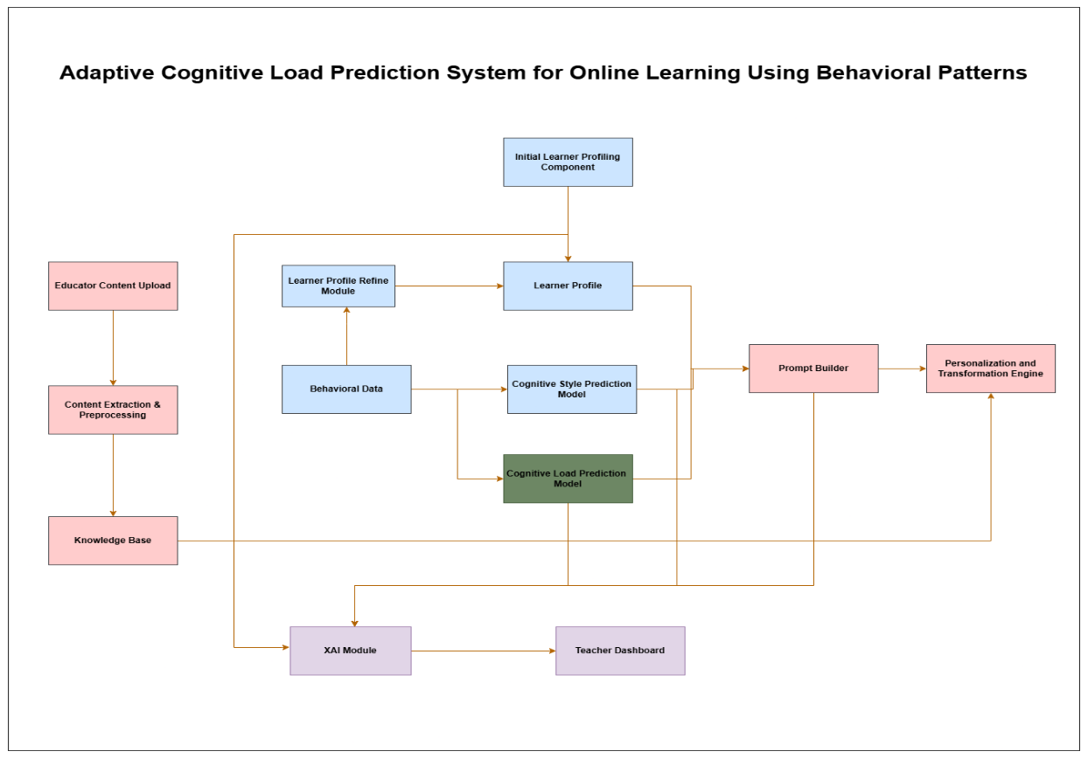
Figure 4 - High-Level Architecture of the Adaptive Cognitive Load Prediction System

Overview of proposed solution and its components
The system is a modular, Retrieval-Augmented Generation (RAG) platform designed to solve the "psychological blind spot" in e-learning [4]. Its primary goal is to transform static, "one-size-fits-all" educational materials into dynamic artifacts that reduce extraneous cognitive load and align with a learner's specific cognitive style and profile [2], [4].
The solution consists of four primary functional components:
- The Input Integration Layer: Receives educator content and real-time parameters (load, style, profile) from external modules.
- The Multimodal Extraction Pipeline: Decomposes heterogeneous files into machine-readable text and symbols.
- The Knowledge Management System: Normalizes, cleans, and stores knowledge in a chunk-wise, traceable format [2], [3].
- Personalization & Transformation Engine: Uses context-aware prompt engineering and GPT-4 to generate the final personalized instructional narrative.
System Component Diagram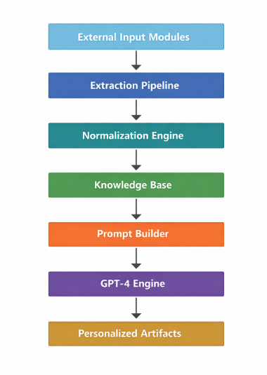
Figure 5 - High-Level System Component and Data Flow of the Personalization Engine

System Component and Subcomponents
This component-based architecture is designed to transform raw educational content into personalized learning artifacts through a structured processing pipeline. The system integrates multiple modules, including input handling, multimodal extraction, preprocessing, knowledge organization, and AI-driven personalization. Each component works together to ensure that learning materials are accurately extracted, cleaned, structured, and adapted to individual learner characteristics. By combining these elements, the framework enables efficient generation of adaptive and personalized educational content.

- The Input Layer
Educator Uploads: Content is uploaded using the ACPLOLS method, which organizes files into steps: Summary, Introduction, Development, Activity, and Assessment [2].
Real-Time Parameter Inputs: Parallel tracking modules (external modules) feed the Cognitive Load (mental workload), Cognitive Style (e.g., visual/verbal), and User Profile (major, year, interests) into the system.

- Multimodal Extraction Pipeline
This component acts as a "semantic parser" to extract meaning from different file formats:
Document Parsers: pdfminer and BeautifulSoup extract text and structure from PDFs and web-based content.
Auditory/Visual Recovery: pydub and OpenVoice process audio/video streams, while OCR (Optical Character Recognition) recovers text and symbols (like arrows or diagrams) from images and slides.

- Preprocessing & Normalization Engine
To ensure the LLM receives high-quality data:
Cleaning: The clean-text library removes HTML tags, special characters, and "noise".
Error Correction: pyspellchecker fixes spelling errors in ASR transcripts to preserve semantic accuracy.

- Chunk-Wise Knowledge Base
Processed content is segmented into knowledge chunks (e.g., definitions, examples, steps).
Each chunk is tagged with metadata (IDs, timecodes, source hash) to ensure 100% back-link coverage, allowing students and teachers to trace any personalized content back to the original source material [3].

- Personalization Engine (GPT-4)
Prompt Builder: Synthesizes a master prompt by combining the User Profile, Cognitive Style, and Load with a specific Knowledge Chunk.
GPT-4 Transformation: Acting as a "skilled narrator," GPT-4 applies pedagogical theories (like Bloom’s Taxonomy or ZPD) to regenerate the content [16]. For example, if "high cognitive load" is detected, it converts a complex text chunk into a simplified, scaffolded explanation.

Interaction Between System Components
- Triggering Adaptation: When the "Load" module detects a spike in the frustration coefficient, it sends a signal to the Prompt Builder.
- Context Matching: The Prompt Builder requests the most relevant Knowledge Chunk from the database using semantic similarity.
- Synthesized Command: The builder issues a command to GPT-4.

Data Flow in the System
- Ingestion: Raw educator files (PDF/PPT/Video) enter the Extraction Pipeline.
- Decomposition: Files are converted to text transcripts and metadata-tagged objects.
- Storage: Objects are "cleaned" and stored in the Knowledge Base.
- Retrieval: Upon a request for a specific lesson, the system retrieves relevant chunks based on the User Profile.
- Generation: GPT-4 processes the chunk + user parameters to output a Personalized Learning Artifact (e.g., an annotated diagram or an exploratory narrative).

Scalability and Security Considerations

Scalability
Cloud Architecture: Hosting the system on AWS or Google Cloud allows for horizontal scaling to support thousands of concurrent users.
Vector Indexing: Using a vector database for the Knowledge Base ensures that retrieval of knowledge chunks remains fast even as the repository grows to millions of items [13].

Security and Privacy
Data Anonymization: Personally identifiable information (PII) is removed via a proxy server architecture before data is sent to the GPT-4 API.
Encryption: The system implements end-to-end encryptions for all sensitive student profile data and emotional feedback logs.
Instructional Rigor: By using Retrieval-Augmented Generation, the system prevents "hallucinations," ensuring that even though the style of delivery changes, the facts remain grounded in the educator's original source material [2].

5.USER REQUIREMENTS
Section 5 describes the stakeholders and system requirements for the proposed adaptive learning platform. It identifies the key users involved in the system, including learners, educators, administrators, and AI developers. The section also defines the functional requirements needed for content processing and personalized learning delivery. In addition, non-functional requirements such as security, performance, usability, and scalability are outlined to ensure reliable system operation.

Stakeholder Identification
- Learners (Undergraduate & Distance Students): The primary users who require personalized instructional materials to reduce boredom, frustration, and cognitive overload.
- Educators (Lecturers/Teachers): Users who provide the source instructional materials (PDFs, PPTs, videos) and set the pedagogical objectives for the system.
- System Administrators: Stakeholders responsible for managing the cloud-based infrastructure, ensuring system security, and maintaining scalability.
- Technologists & AI Developers: The team responsible for maintaining the multimodal extraction pipeline, GPT-4 integration, and knowledge base.

Functional Requirements
- Multimodal Resource Upload: The system shall allow educators to upload instructional content in various formats, including PDFs, PPTs, images, and videos [1].
- Automated Decomposition: The system shall utilize ASR and OCR to extract discrete, timestamped knowledge units (definitions, steps, and prompts) from the uploaded source materials.
- Text Normalization: The system shall automatically clean and normalize extracted text using clean-text and pyspellchecker to ensure semantic accuracy for the transformation engine.
- Contextual Content Transformation: Utilizing GPT-4, the system shall convert standard lessons into personalized formats (e.g., exploratory narratives or scaffolded diagrams) that match the user’s cognitive style and profile.
- Traceable Knowledge Storage: All processed chunks shall be stored in a structured knowledge base with explicit backlinks to the exact time and location in the original source material [2].

Non-functional requirements
- Security and Privacy:
The system shall implement end-to-end encryption for all learner profile and emotional data.
All data sent to third-party APIs shall be anonymized via a proxy server to prevent the exposure of personally identifiable information.
- Performance and Latency:
The system shall maintain a processing latency of ≤ 2× the clip duration for end-to-end decomposition and adaptation [3].
- Usability and Accessibility:
The interface shall provide clear progression markers and scaffolding to keep students within their Zone of Proximal Development.
- Reliability and Accuracy:
The system shall utilize Retrieval-Augmented Generation (RAG) to prevent AI "hallucinations" and ensure all content is factually grounded in the teacher's original material.
- Scalability:
The system shall be hosted on cloud infrastructure (e.g., AWS or Google Cloud) to support thousands of concurrent users and real-time data processing across multiple regions.

6.COMMERCIALIZATION PLAN

Target market and customer persona

The primary target market for the adaptive learning platform consists of higher education institutions, online learning platforms, and distance education providers that require personalized learning support for diverse student populations. Universities and e-learning providers increasingly seek intelligent systems capable of adapting learning materials according to individual learner needs, particularly in large-scale online courses where manual personalization by instructors is not feasible.

The system is especially suitable for undergraduate students, distance learners, and adult learners who experience varying levels of cognitive load and learning styles when engaging with instructional content. Many learners struggle to understand complex materials presented in a single static format, leading to frustration, reduced engagement, and lower learning outcomes.

A typical customer persona includes educators and instructional designers responsible for delivering course materials through Learning Management Systems (LMS). These users upload instructional resources such as PDFs, presentations, videos, and images into the platform. The system then automatically converts these resources into personalized explanations tailored to each learner’s cognitive load level, cognitive style, and learner profile.

Therefore, the platform targets both educational institutions seeking scalable personalization solutions and students who require adaptive learning support to improve comprehension and reduce cognitive overload.

Value proposition

The proposed system provides an AI-driven adaptive learning solution that automatically converts instructional materials into personalized learning explanations based on learner cognitive characteristics.

Traditional Learning Management Systems typically deliver identical learning materials to all students, regardless of their cognitive abilities, learning styles, or current cognitive load. This one-size-fits-all approach often results in learners experiencing cognitive overload, boredom, or difficulty understanding complex concepts.

The proposed platform addresses this challenge by integrating cognitive load prediction, cognitive style detection, and AI-based content transformation. Educators upload learning resources, which are automatically processed and decomposed into structured knowledge units. These units are then transformed into personalized explanations using a large language model guided by prompts generated from learner profiles.

The key value offered by the system includes:
- Automated personalization of learning materials
- Reduction of learner cognitive overload
- Improved comprehension through adaptive explanations
- Scalable personalization for large classrooms
- Seamless integration with educator-provided materials
- By dynamically adapting content presentation to the learner’s cognitive characteristics, the system enhances learning efficiency, engagement, and educational outcomes.

Revenue model
The adaptive learning platform can adopt a Software-as-a-Service (SaaS) revenue model, where educational institutions subscribe to the platform based on usage and scale.

Under this model, universities, online education platforms, and training organizations pay a subscription fee to access the system’s personalization capabilities. The platform processes uploaded educational content and delivers adaptive explanations to students through the learning interface.

Potential revenue streams include:

Institutional Subscription Plans
- Universities and colleges pay an annual license to integrate the system with their LMS.
Per-Student Licensing
- Institutions pay a fee based on the number of active learners using the platform.
API Integration Services
- EdTech companies or LMS providers can integrate the personalization engine through APIs.
Premium Personalization Features
- Advanced analytics dashboards for educators to monitor cognitive load, engagement, and learning progress.
- This model enables scalable revenue while allowing institutions to deploy the system across large student populations.

Cost estimation
The operational costs of the platform primarily arise from cloud infrastructure, AI model usage, system development, and maintenance.

Key cost components include:
Cloud Infrastructure
- Hosting servers for storing educational resources and knowledge bases
- Database management for chunked learning content
- Storage for multimedia resources
AI Model Usage
- API usage costs for large language models such as GPT-4 used in content transformation
- Computational resources required for generating personalized explanations

Development and Maintenance
- Software engineering for maintaining the content extraction pipeline
- Updates to ASR, OCR, and multimodal extraction modules
- Continuous improvement of prompt engineering strategies
Data Processing
- Tools and libraries used for text extraction, cleaning, and normalization
- By leveraging cloud-based infrastructure and modular AI services, the system can scale efficiently while maintaining manageable operational costs.

Pricing strategy

The platform will adopt a tiered pricing strategy designed to accommodate different types of educational institutions.

Possible pricing tiers include:
Basic Tier
- Suitable for small institutions or pilot deployments
- Limited number of courses and students
- Basic personalization features
Standard Tier
- Designed for universities and online learning providers
- Full access to adaptive content conversion
- Cognitive load and learning style personalization
Enterprise Tier
- Large-scale deployment for national education platforms
- API integration with existing LMS systems
- Advanced analytics and monitoring tools

This pricing strategy ensures accessibility for smaller institutions while generating higher revenue from large educational organizations.

Competitive advantage

The proposed system offers several competitive advantages compared to traditional LMS platforms and existing adaptive learning systems.

AI-Based Dynamic Content Conversion
Unlike many adaptive systems that only recommend existing learning objects, the proposed system dynamically rewrites and converts instructional content using AI to match learner cognitive characteristics.

Cognitive Load-Aware Personalization
The platform integrates cognitive load prediction mechanisms, allowing the system to adjust explanation complexity based on learner mental effort levels.

Multimodal Content Processing
The system supports multiple instructional resource formats including:
- PDFs
- PPT presentations
- Images
- Videos
- Diagrams
These resources are automatically extracted and transformed into structured knowledge units.

Automated Prompt-Based Personalization
The system generates structured prompts using learner profiles and cognitive attributes, enabling the AI model to produce tailored explanations.
This combination of multimodal content extraction, cognitive modeling, and AI-driven transformation provides a more advanced personalization capability than most existing learning platforms.

Intellectual property considerations
The system includes several components that may qualify for intellectual property protection.
Software and System Architecture

The platform’s architecture, including the multimodal extraction pipeline, knowledge chunking mechanism, and prompt-based personalization framework, can be protected through software copyright.

Algorithmic Workflow
The integration of cognitive load prediction, cognitive style detection, and AI-based content transformation represents a novel workflow that may be eligible for intellectual property protection.
Prompt Engineering Framework
The structured prompt builder that combines learner profile data with knowledge base content to generate adaptive explanations could also be considered a proprietary component.
Additionally, the system must comply with data protection and privacy regulations when handling learner profiles and behavioral data. Proper safeguards should be implemented to ensure secure storage and ethical use of educational data.

7.BUDGET AND JUSTIFICATION
Table 2 - Budget and Justification
Cost Category | Item / Resource | Estimated Cost (USD) | Justification
Hardware Costs | Development laptops/workstations | $1,500 – $2,000 | Required for developers to run AI tools, data processing libraries, and development environments for implementing the system modules.
 | External storage / backup drives | $100 – $200 | Used for storing extracted datasets, multimedia educational resources, and system backups during development and testing.
Software Licenses | Development tools (IDE such as PyCharm / VS Code extensions) | $0 – $200 | Provides an efficient development environment for coding, debugging, and managing Python-based modules used in the system.
 | Python libraries (OCR, NLP, text processing) | Mostly Free (Open Source) | Libraries such as pdfminer, BeautifulSoup, clean-text, pyspellchecker, and pydub are open-source tools used for content extraction and preprocessing.
 | AI model access (GPT-4 API usage) | $50 – $200 per month (estimated) | Required for generating personalized explanations through the prompt-based content transformation process.
Cloud Services | Cloud hosting (AWS / Google Cloud / Azure) | $50 – $150 per month | Used to host the system backend, store the knowledge base, and handle user requests for personalized learning content.
 | Cloud storage (database + multimedia resources) | $20 – $80 per month | Stores uploaded educational materials such as PDFs, PPTs, images, and videos as well as processed knowledge chunks.
 | Vector database / database hosting | $20 – $100 per month | Enables efficient storage and retrieval of knowledge chunks used in the Retrieval-Augmented Generation (RAG) process.
Human Effort Cost | AI/Software developers | $3,000 – $6,000 (project effort estimate) | Developers are required to design the extraction pipeline, implement the prompt builder, integrate GPT models, and build the adaptive learning system.
 | System testing and evaluation | $500 – $1,000 | Effort required for testing system performance, validating personalized content generation, and improving system reliability.
 | Maintenance and system updates | $500 – $1,500 | Continuous improvements, bug fixes, and system optimization after deployment.
Total Estimated Cost (Development Phase) | — | Approximately $5,000 – $11,000 | Covers development infrastructure, AI services, and human effort required to implement the adaptive learning platform.

8.WORK BREAKDOWN STRUCTURE (WBS)
Table 3 – Work Breakdown Structure
WBS ID | Task | Duration | Deliverable | Dependencies
4.1 | Literature Review (Adaptive Learning & Cognitive Load) | 6 weeks | Annotated bibliography, research summary | None
4.2 | API and Data Flow Design with Team Modules | 3 weeks | API specifications for receiving cognitive load, cognitive style, and learner profile | 4.1
4.3 | System Architecture Design | 4 weeks | System design document, architecture diagram | 4.2
4.4 | Knowledge Base and Database Implementation | 3 weeks | Knowledge base schema, chunked content storage | 4.3
4.5 | Multimodal Content Extraction Module | 4 weeks | Working extraction pipeline using PDFMiner, OCR, ASR, and media processing tools | 4.4
4.6 | Text Cleaning and Preprocessing Module | 3 weeks | Cleaned and normalized text dataset using clean-text and pyspellchecker | 4.5
4.7 | Prompt Builder and Personalization Logic Development | 5 weeks | Prompt generation system using cognitive load, cognitive style, and learner profile | 4.6
4.8 | GPT-4 Integration for Adaptive Content Generation | 3 weeks | Working personalized content generation module | 4.7
4.9 | Integration with Other Team Modules | 3 weeks | End-to-end workflow from learner input to personalized output | 4.8
4.10 | Testing and Evaluation | 6 weeks | Evaluation report, learner feedback, performance analysis | 4.9

9.GANTT CHART

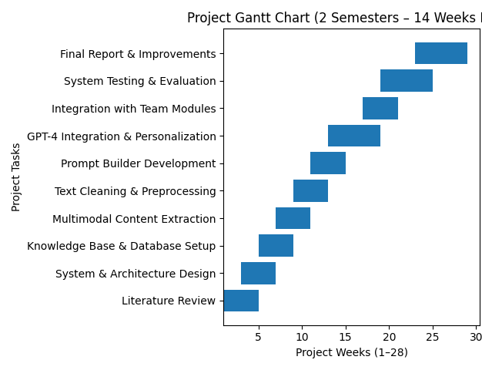
Figure 6 – Gantt Chart

10.REFERENCES LIST
[1] T. Kabudi, I. Pappas, and D. H. Olsen, “AI-enabled adaptive learning systems: A systematic mapping of the literature,” Comput. Educ. Artif. Intell., vol. 2, Art. no. 100017, 2021. doi: 10.1016/j.caeai.2021.100017.
[2] J. J. Y. Lim et al., “Learning in Context: Personalizing Educational Content with Large Language Models to Enhance Student Learning,” [Publication Title], vol. 1, no. 1, pp. 1–19, Sep. 2025. doi: 10.1145/XXXXXXXXXXXXX.
[3] L. Nouraei Yeganeh, Y. Chen, N. S. Fenty, A. Simpson, and M. Hatami, “STREAM: A Semantic Transformation and Real-Time Educational Adaptation Multimodal Framework in Personalized Virtual Classrooms,” Future Internet, vol. 17, no. 12, Art. no. 564, Dec. 2025. doi: 10.3390/fi17120564.
[4] W. Hu and Z. Shao, “Design and evaluation of a GenAI-based personalized educational content system tailored to personality traits and emotional responses for adaptive learning,” Comput. Hum. Behav. Rep., vol. 19, Art. no. 100735, 2025. doi: 10.1016/j.chbr.2025.100735.
[5] Z. Hu, “A method for generating personalized learning content based on AIGC,” Sustain. Futur., vol. 7, Art. no. 100735, 2025. doi: 10.1016/j.sftr.2025.100735.
[6] B. L. Reddy, Nirmala, V. Lathika, M. Vidhyasree, V. Manimegalai, and K. Kavya, "Personalized Learning Systems Using AI for Adaptive Educational Content Delivery Based on Reinforcement Learning Algorithms," in 2025 3rd Int. Conf. Commun. Security Artif. Intell. (ICCSAI), 2025, pp. 960–964. doi: 10.1109/ICCSAI64074.2025.11064584.
[7] B. Ogunleye, O. S. Okonkwo, O. O. Ajayi, O. E. Olaniyi, S. O. Oladipo, and T. A. Adeyemi, "Artificial intelligence in education: A review of personalized learning and educational technology," GSC Adv. Res. Rev., vol. 18, no. 2, pp. 261–271, 2024. doi: 10.30574/gscarr.2024.18.2.0062.
[8] M. Y. Al Balushi and A. S. Al Harthi, "Adaptive Learning Pathways: Advancing Personalization in Online Education Platforms," Int. J. Virtual Pers. Learn. Environ., vol. 13, no. 1, pp. 1–15, 2023. doi: unavailable.
[9] W. Strielkowski, V. Grebennikova, A. Lisovskyi, G. Rakhimova, and T. Vasileva, "AI-driven adaptive learning for sustainable educational transformation," Sustain. Dev., vol. 33, no. 2, pp. 1921–1947, 2025. doi: 10.1002/sd.3221.
[10] C. Diwan, S. Srinivasa, G. Suri, S. Agarwal, and P. Ram, "AI-based learning content generation and learning pathway augmentation to increase learner engagement," Comput. Educ. Artif. Intell., vol. 7, Art. no. 100110, 2024. doi: 10.1016/j.caeai.2024.100110.
[11] S. Natarajan, S. Das, S. Srinivasan, W. Stammer, and K. Kersting, "Human-in-the-loop or AI-in-the-loop?" [Unpublished manuscript], 2025.
[12] M. Guettala, S. Bourekkache, O. Kazar, and S. Harous, "Generative Artificial Intelligence in Education: Advancing Adaptive and Personalized Learning," Acta Inform. Pragensia, vol. 13, no. 3, pp. 460–489, 2024. doi: 10.18267/j.aip.235.
[13] A. K. Pani, S. Thalla, L. Lavanya, K. Sudhakar, and S. Gurumoothry, "Hybrid Knowledge-Enhanced Personalized Learning Recommendation Model for Adaptive and Intelligent Educational Systems," in 2025 2nd Int. Conf. Softw. Syst. Inf. Technol. (SSITCON), 2025, pp. 1–6. doi: 10.1109/SSITCON64747.2025.11012345.
[14] D. Rooein, A. Cercas Curry, and D. Hovy, "Know Your Audience: Do LLMs Adapt to Different Age and Education Levels?," arXiv preprint, arXiv:2312.02065, Dec. 2023. [Online]. Available: https://arxiv.org/abs/2312.02065
[15] G. Tilak, D. Singh, D. Chakravorty, J. Patole, G. P. Kable, and N. Anute, "Multimodal AI-Enabled Learning Personalization," in Proc. Int. Conf. Emerg. Trends Electr. Electron. Sustain. Energy Syst. (ICETEESES), 2025, pp. 1–6. doi: 10.1109/ICETEESES.2025.1234567.
[16] T. F. Heston and C. Kuhn, "Prompt Engineering in Medical Education: Using artificial intelligence to accelerate learning and deepen understanding," Unpublished manuscript, 2023. [Online]. Available: https://www.researchgate.net/publication/372516582_Prompt_Engineering_in_Medical_Education
[17] Z. C. da Silva, A. R. Pimentel, and L. R. Ferreira, "Learning Objects Content Presentation Adaptation Model Considering Students' Learning Styles," Int. J. Educ. Pedagog. Sci., vol. 15, no. 8, pp. 783–790, 2021. doi: 10.5281/zenodo.10012193.

